# Problem

Sometimes corporations need to buy parts from suppliers, but different suppliers offer the same parts at different prices and delivery times. Corporate buyers need to know which suppliers supply which parts in order to achieve manufacturing production schedules.

# Sample Database

Suppliers

|  |  |  |  |  |
| --- | --- | --- | --- | --- |
| id | name | contact | phone | email |
| 1 | XYZ Corp | Jane Seymour | 989.777.1111 | jane@xyz.com |
| 2 | ABC Enterprises | Bob Bober | 616.999.2222 | bobby@abc.com |
| 3 | PDQ Inc | Lisa Mulligan | 313.444.5555 | lisa@pdq.com |
| 4 | ASAP LLC | Jim Slade | 734.222.8888 | jim@asap.com |

Parts

|  |  |  |  |  |
| --- | --- | --- | --- | --- |
| id | name | number | length | width |
| 1 | Plex Joint | SDF-1234567-Q | 12 | 6 |
| 2 | Widget | XX2-9099999-R | 19 | 45 |
| 3 | Doohickey | ZZZ-0000001-Q | 32 | 12 |
| 4 | Thingamabob | SDF-1111111-Q | 7 | 15 |

SupplierParts

|  |  |  |  |  |
| --- | --- | --- | --- | --- |
| id | supplier_id | part_id | cost | delivery_days |
| 1 | 1 | 1 | $12.00 | 6 |
| 2 | 1 | 2 | $19.32 | 45 |
| 3 | 1 | 3 | $32.11 | 12 |
| 4 | 1 | 4 | $0.07 | 15 |
| 5 | 2 | 1 | $11.00 | 10 |
| 6 | 2 | 2 | $39.02 | 14 |
| 7 | 2 | 3 | $99.00 | 5 |
| 8 | 3 | 1 | $0.08 | 15 |
| 9 | 3 | 2 | $9.99 | 99 |
| 10 | 3 | 4 | $0.08 | 30 |
| 11 | 4 | 3 | $20.99 | 75 |
| 12 | 4 | 4 | $0.09 | 45 |

Entity Relationship Diagram



Screen Flow Diagram



Wireframe Diagram



There must be one wireframe FOR EACH element of the SCREEN FLOW DIAGRAM

Screenshot

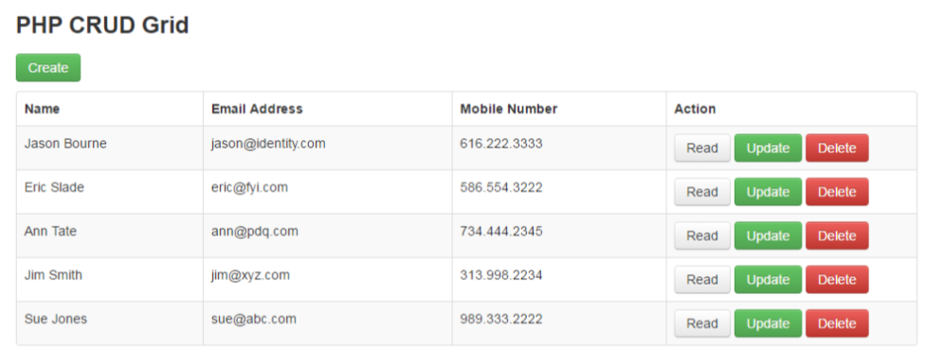

Use case diagram

